HOMEWORK FOR BABY CLASS TERM I 2024
ENGLISH NO. 1
My name is ..............................................................................
Shade the pot

Comment: ____________________________________
Parent’s signature: _______________________________

HOMEWORK FOR BABY CLASS TERM I 2024
ENGLISH NO. 2
My name is ..............................................................................
Shade the ball

Comment: ____________________________________
Parent’s signature: _______________________________

HOMEWORK FOR BABY CLASS TERM I 2024
ENGLISH NO. 3
My name is ..............................................................................
Trace the ball

Comment: ____________________________________
Parent’s signature: _______________________________

HOMEWORK FOR BABY CLASS TERM I 2024
ENGLISH NO. 4
My name is ..............................................................................
Trace the tin

Comment: ____________________________________
Parent’s signature: _______________________________

HOMEWORK FOR BABY CLASS TERM I 2024
ENGLISH NO. 5
My name is ..............................................................................
Trace the book

Comment: ____________________________________
Parent’s signature: _______________________________

HOMEWORK FOR BABY CLASS TERM I 2024
ENGLISH NO. 6
My name is ..............................................................................
Shade the girl

Comment: ____________________________________
Parent’s signature: _______________________________

HOMEWORK FOR BABY CLASS TERM I 2024
ENGLISH NO. 7
My name is ..............................................................................
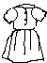
Match the same.
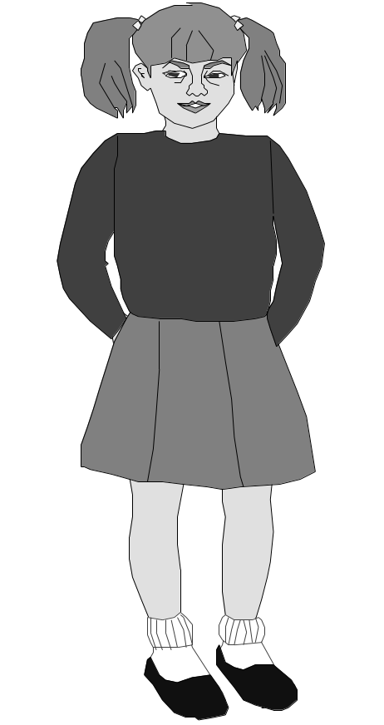

Comment; ________________________________________
Signature: _______________________________________

HOMEWORK FOR BABY CLASS TERM I 2024
ENGLISH NO. 8
My name is ..............................................................................
Shade the cat.

Comment: ____________________________________
Parent’s signature: _______________________________

HOMEWORK FOR BABY CLASS TERM I 2024
NUMBERS NO. 1
My name is ..............................................................................
Shade number 1.

Comment: ____________________________________
Parent’s signature: _______________________________

HOMEWORK FOR BABY CLASS TERM I 2024
NUMBERS NO. 2
My name is ..............................................................................
Count and trace number 2

Comment: ____________________________________
Parent’s signature: _______________________________

HOMEWORK FOR BABY CLASS TERM I 2024
NUMBERS NO. 3
My name is ..............................................................................
Trace number 3.
Count the girls
= 3

Comment: ____________________________________
Parent’s signature: _______________________________

HOMEWORK FOR BABY CLASS TERM I 2024
NUMBERS NO. 4
My name is ..............................................................................
Trace number 4
Count.
 = 4

Comment: ____________________________________
Parent’s signature: _______________________________

HOMEWORK FOR BABY CLASS TERM I 2024
NUMBERS NO. 5
My name is ..............................................................................
Match and write

1 4 __4__

2 3 _____

3 2 _____

4 1 _____

HOMEWORK FOR BABY CLASS TERM I 2024
NUMBERS NO. 6
My name is ..............................................................................
Count and trace.
= 5

Comment: ____________________________________
Parent’s signature: _______________________________

HOMEWORK FOR BABY CLASS TERM I 2024
NUMBERS NO. 7
My name is ..............................................................................
Circle the same.
1 2 3 4 5

2 4 2 1

4 1 1 3 4

5 5 2 1

3 4 3 5

Comment: ____________________________________
Parent’s signature: _______________________________

HOMEWORK FOR BABY CLASS TERM I 2024
NUMBERS NO. 8
My name is ..............................................................................
Match and trace

Trace

HOMEWORK FOR BABY CLASS TERM I 2024
NUMBERS NO.9
My name is ..............................................................................
Count and circle.
4 3 2

2 1 5

3 5 2

4 7 1

5 6 3

1 2 3 4 5
__ __ __ ___ ___

HOMEWORK FOR BABY CLASS TERM I 2024
READING NO. 1
My name is ..............................................................................
Shade sound a

Comment: ____________________________________
Parent’s signature: _______________________________

HOMEWORK FOR BABY CLASS TERM I 2024
READING NO. 2
My name is ..............................................................................
Shade sound b

Comment: ____________________________________
Parent’s signature: _______________________________

HOMEWORK FOR BABY CLASS TERM I 2024
READING NO. 3
My name is ..............................................................................
Shade sound c

Comment: ____________________________________
Parent’s signature: _______________________________

HOMEWORK FOR BABY CLASS TERM I 2024
READING NO. 4
My name is ..............................................................................
Shade sound d

Comment: ____________________________________
Parent’s signature: _______________________________

HOMEWORK FOR BABY CLASS TERM I 2024
READING NO. 5
My name is ..............................................................................
Shade sound e

Comment: ____________________________________
Parent’s signature: _______________________________

HOMEWORK FOR BABY CLASS TERM I 2024
READING NO. 6
My name is ..............................................................................
Match the same sounds.
a e
b d
c c
d b
e a

Comment: ____________________________________
Parent’s signature: _______________________________

HOMEWORK FOR BABY CLASS TERM I 2024
READING NO. 7
My name is ..............................................................................
Circle the same sounds.
b e c
c a d
b a d e c b

a d b
a c b
c b d e c d

Comment: ____________________________________
Parent’s signature: _______________________________

HOMEWORK FOR BABY CLASS TERM I 2024
READING NO. 8
My name is ..............................................................................
Copy again
a
b
c
d
e

Comment: ____________________________________
Parent’s signature: _______________________________

HOMEWORK FOR BABY CLASS TERM I 2024
READING NO. 9
My name is ..............................................................................
Circle the same.
b b a
a a
b c a

e e e d
d e d d

c c a c
Comment: ______________________________________
Parent’s signature: _______________________________

HOMEWORK FOR BABY CLASS TERM I 2024
APTITUDE/WRITING NO. 1
My name is ..............................................................................
Shade the picture.

Trace

HOMEWORK FOR BABY CLASS TERM I 2024
APTITUDE/WRITING NO. 2
My name is ..............................................................................
Trace the fingers

Trace

HOMEWORK FOR BABY CLASS TERM I 2024
APTITUDE/WRITING NO. 3
My name is ..............................................................................
Shade.

Trace

HOMEWORK FOR BABY CLASS TERM I 2024
APTITUDE/WRITING NO. 4
My name is ..............................................................................
Shade

Trace

HOMEWORK FOR BABY CLASS TERM I 2024
APTITUDE/WRITING NO. 5
My name is ..............................................................................
match to the same.



Trace

HOMEWORK FOR BABY CLASS TERM I 2024
APTITUDE/WRITING NO. 6
My name is ..............................................................................
Trace the picture.

Match
l c

____ _____

C l
HOMEWORK FOR BABY CLASS TERM I 2024
APTITUDE/WRITING NO. 7
My name is ..............................................................................
Trace

Trace

HOMEWORK FOR BABY CLASS TERM I 2024
APTITUDE/WRITING NO. 8
My name is ..............................................................................
Match to the same.

Copy

HOMEWORK FOR BABY CLASS TERM I 2024
APTITUDE/WRITING NO. 9
My name is ..............................................................................
Shade the cat

Copy

